Long Branch Free Public Library
submitted by Lisa Kelly

A passionate book discussion of The Brief Wondrous Life of Oscar Wao was hosted by the Long Branch Free Public Library and the Elberon Book Club. To enhance this discussion, members enjoyed listening to music from the Dominican Republic while feasting on chicken and beef empanadas with spicy sauce and fried plantains. The discussion turned out to be “spicy” as well, with many heated opinions about the book’s content. As noted by Lisa Kelly: “In the end, we agreed to disagree about exactly how wondrous Oscar Wao’s life was, but all of our book club members rallied behind our decision to read the One Book NJ selection, realizing it presented an opportunity to stretch our reading wings and move outside our comfort zone . . ..” The OBNJ Committee honors this program for its true commitment to sharing ideas and an appreciation of literature within the community. The Committee was further impressed by the library’s insight to combine OBNJ programming with the state’s Snapshot Day (and loved the submitted snapshots, too).

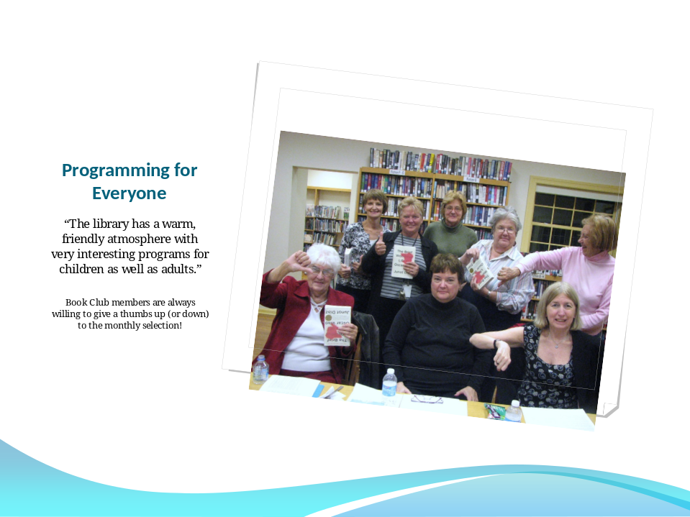

One Book NJ is presented by the New Jersey State Library Association in collaboration with and funded by the New Jersey State Library, which is responsible for the coordination, promotion, and funding of the New Jersey Library Network.

