Adult Read-Alikes for
The Curious Incident of the Dog in the Night-Time
by Mark Haddon

As Dog is My Witness by Jeffrey Cohen
A freelance writer becomes involved in solving the mystery of whether or not a teen with Asperger's Syndrome was guilty of murder, even in spite of the teen's confession to the crime.

Thinking in Pictures by Temple Grandin
The true story of a woman’s incredible ability to empathize with animals and how it was shaped by her autism.

The Ride Together by Judy Karasik
Written as both a memoir and graphic novel, this book provides a balanced portrait of autism.

Child of Silence by Abigail Padgett
In the Bo Bradley series of mysteries, Bo is a manic-depressive social worker who is treating her illness with medication but uses her personal experience to connect with the people her job brings her into contact with.

Marcelo in the Real World by Francisco X. Stork
On the high-functioning end of the autistic spectrum, Marcelo would rather live in his own world, but when he strikes a deal with his dad, he must work his way though the mailroom at his dad’s law firm in “the real world.”

Born on a Blue Day by Daniel Tammet
An autistic savant with genius-level mathematical talents describes how he was shunned by his classmates in spite of his super-human capacity for math and language and offers insight into how he experiences the world.

Young Adult Read-Alikes for
The Absolutely True Diary of a
Part-Time Indian
by Sherman Alexie

The Way by Joseph Bruchac
Cody LeBeau, who is fatherless and an Abenaki Indian, is the new kid at school and the new target for the bullies, but things begin to change when his uncle comes to town for a martial arts competition and he and Cody begin training together.

Moccasin Thunder : American Indian Stories for Today edited by Lori Marie Carlson
Presents ten short stories about contemporary Native American teens by members of tribes of the United States and Canada, including Louise Erdrich and Joseph Bruchac.

Dark Dude by Oscar Hijuelos
In the 1960s, Rico Fuentes, a pale-skinned Cuban American teenager, abandons drug-infested New York City for the picket fence and apple pie world of Wisconsin, only to discover that he still feels like an outsider and that violent and judgmental people can be found even in the wholesome Midwest.

Poison Ivy by Amy Goldman Koss
In a government class three popular girls undergo a mock trial for their ruthless bullying of a classmate.

Black and White by Paul Volponi
Marcus, black, and Eddie, white, are both star basketball players. But when they both commit the same crime, the justice system treats them differently.

Middle Grade Read-Alikes for
The Tale of Despereaux
by Kate DiCamillo

Into The Wild by Sarah Beth Durst
Julie’s mother, Rapunzel, escaped from The Wild, the dangerous world of fairy tales. Now The Wild wants her and the other escaped characters back and it seems that only Julie can help them. Julie’s adventures continue in Out of The Wild.

The Courageous Princess by Rod Espinosa
In this graphic novel, Princess Mabelrose is captured by a dragon, escapes, and tries to find her way home with the help of her sidekick, a talking porcupine.

Igraine the Brave by Cornelia Funke
With the family castle under siege and her wizard parents transformed into pigs, it is up to Igraine, who has always wanted to be a knight, to escape from the castle and find help.

Redwall by Brian Jacques
Cluny, the one-eyed rat, is coming to conquer the peaceful mice who live in the abbey of Redwall. The latest adventure in this multi-volume series, due out in 2010, is The Sable Quean.

You Wouldn’t Want to Be a Medieval Knight by Fiona Macdonald
One of a popular series of “You Wouldn’t Want to Be” books, this one lets readers in on what live was really like in the middle ages.

The Cricket in Times Square by George Selden
Chester the cricket has found a comfortable home in Times Square and has met three good friends: a young boy named Tony, Harry the Cat, and Tucker the Mouse.

Read to Me Read-Alikes for
Click, Clack, Moo : Cows That Type
by Doreen Cronin

Kid Blink Beats the World by Don Brown
In the summer of 1899, hundreds of young news vendors held a strike against two of the most powerful men in the U.S. – William Randolph Hearst and Joseph Pulitzer – for the extra penny they wanted to charge the vendors to buy their papers.

Minnie and Moo Go To the Moon by Denys Cazet
This is the first adventure in this funny easy reader series about two cows who can never stay out of trouble.

Giggle Giggle Quack by Doreen Cronin
Farmer Brown takes a vacation leaving his brother Bob in charge with detailed instructions on keeping the animals in line. Unfortunately for Bob, Duck finds the pencil and has some ideas of his own.

A Particular Cow by Mem Fox
Every day a particular cow goes for a particular walk, until the day when a pair of bloomers falls off the clothesline, covers her eyes and causes one catastrophe after another.

Clorinda by Robert Kinerk
Clorinda is a contented cow until the day she sees her first ballet and sets her sights on becoming a ballerina. This funny story of a cow in a tutu is followed by Clorinda Takes Flight.

Chicks and Salsa by Aaron Reynolds
What happens on the farm when the chickens decide they are tired of the same old chicken feed? With the help of a savvy rooster and a few ingredients “borrowed” from the garden, soon the whole farm is feasting on salsa and guacamole!



For more information on One Book NJ, visit our website at
www.onebooknewjersey.org

OBNJ is a project of the New Jersey Library Association and the New Jersey State Library


These and other titles can be found in the BCCLS catalog. If Franklin Lakes Public Library does not own the book, we can request it for you from another library. Ask a librarian!


Use our online catalog
to satisfy all your reading needs.
BCCLS [www.bccls.org]

Created by
The One Book New Jersey Committee
& Franklin Lakes Public Library
470 De Korte Drive
Franklin Lakes, NJ 04717
201-891-2224
www.franklinlakeslibrary.org

jan10 kmv
Read-alikes
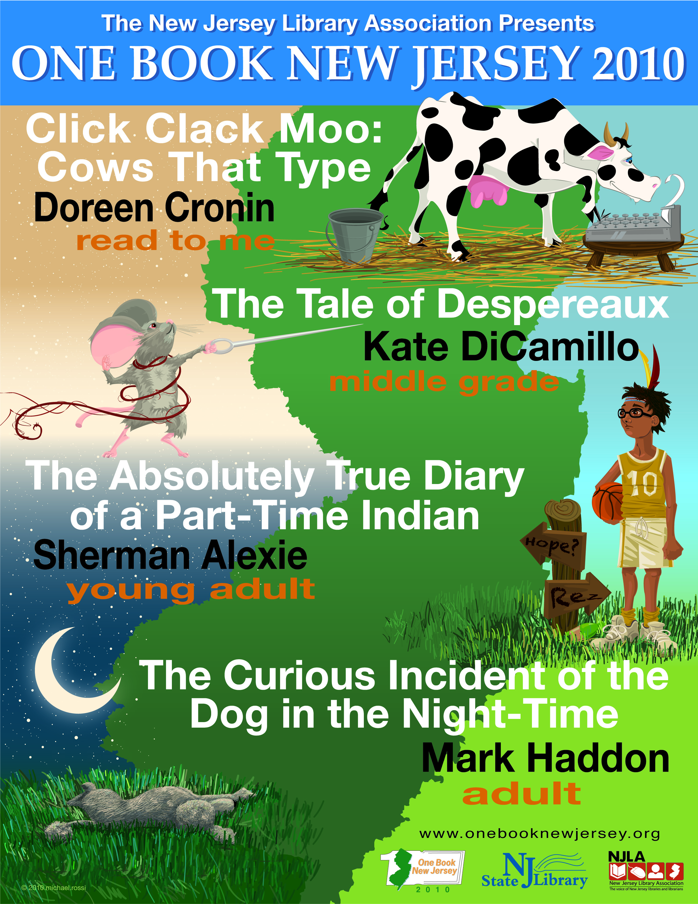
OBNJ 2010

